### Dataset:

<https://docs.google.com/spreadsheets/d/1IRSEnmgz8Ro276-GslknRNk0zlrB5CZH1YrnT71kqFM/edit?usp=sharing>.

### Use the above dataset and answer the following questions.

### 1. What is the total amount of stationary bought from Madhya Pradesh?

#### Ans:

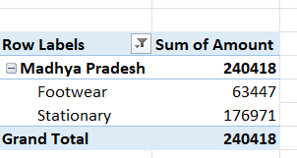

### 2. What is the total count of stationary bought from Tamilnadu?

#### Ans:

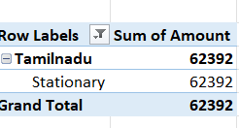

### 3. What is the total amount spent on footwear?

#### Ans:

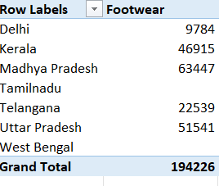

### 4. What is the total amount of money spent for stationary in July?

#### Ans:

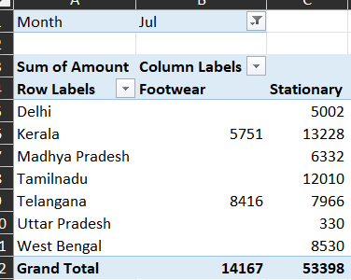

### 5. What is the count of footwear that is coming from Delhi?

#### Ans:

